
www.kingston-saddlery.com
QUALITY ALWAYS WINS
875 STILLWATER ROAD SUITE 200 WEST SACRAMENTO, CA 95605
Phone: (916)996-0711 Fax: (530)753-4505
E-mail: kingstonsaddlery@yahoo.com & sales@kingston-saddlery.com
ASSEMBLY OF THE SHAFT (07 style)
GROUPWARE
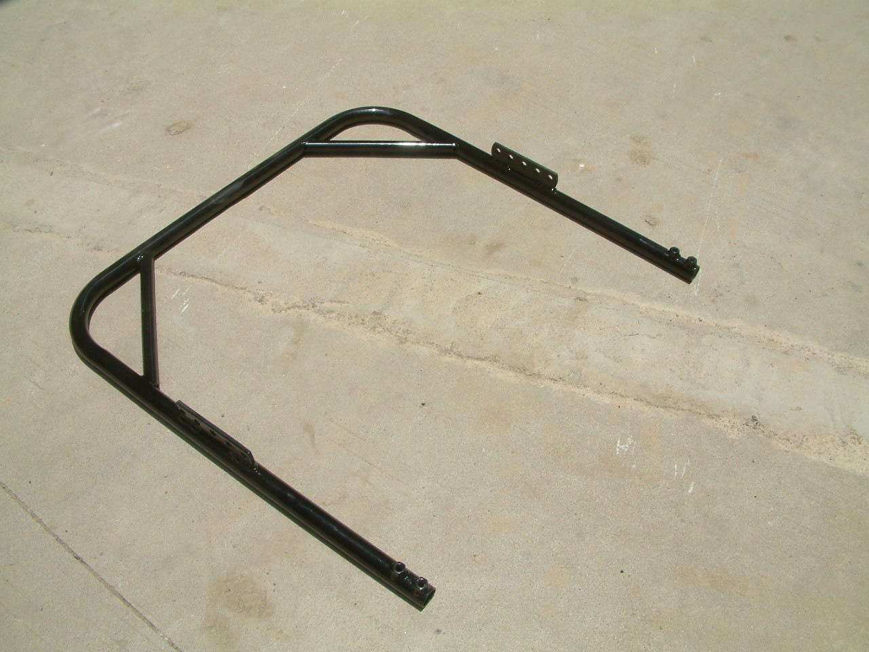 | 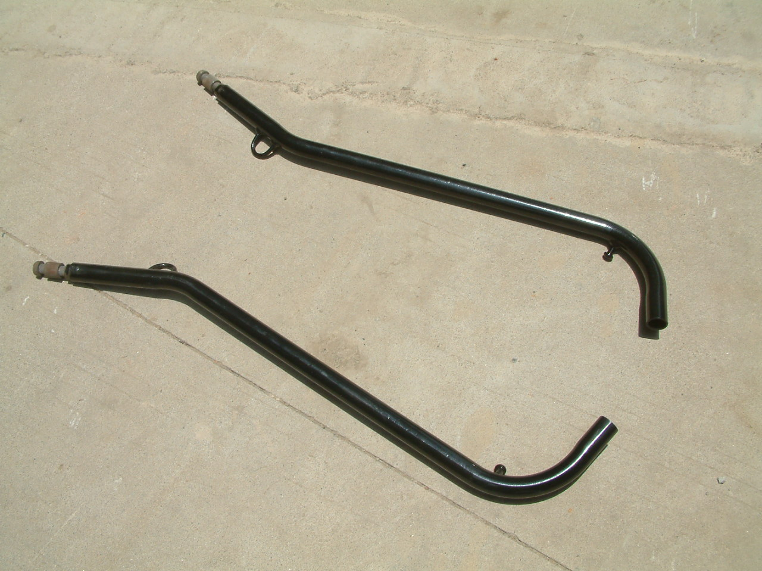 |  | 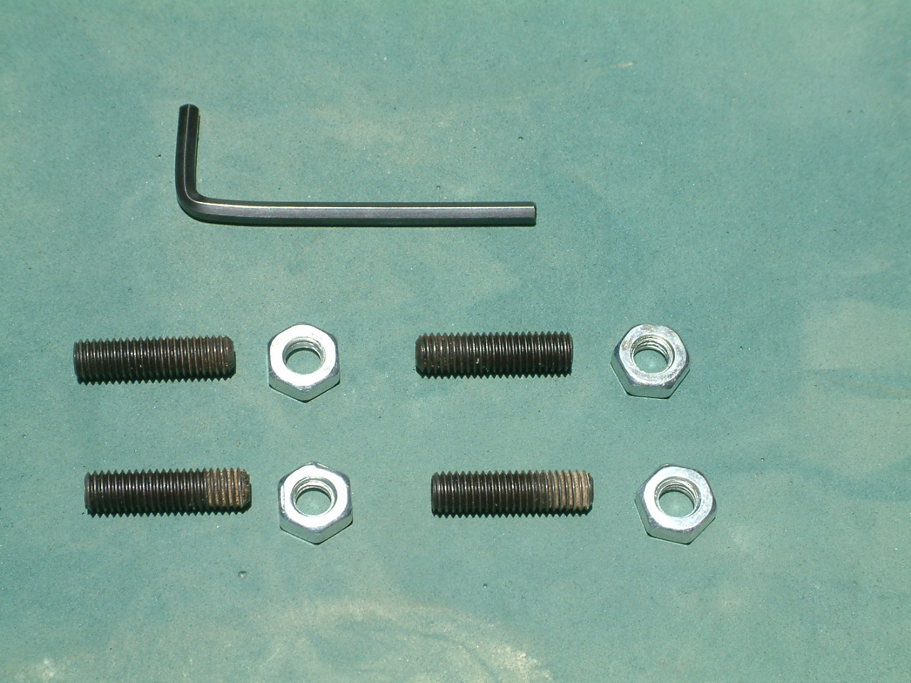
（1）Shaft – A part | （2）Shaft- B part × 2 |  | （3）Bolt ×4 Nut ×4 Tool
INSTALLATION
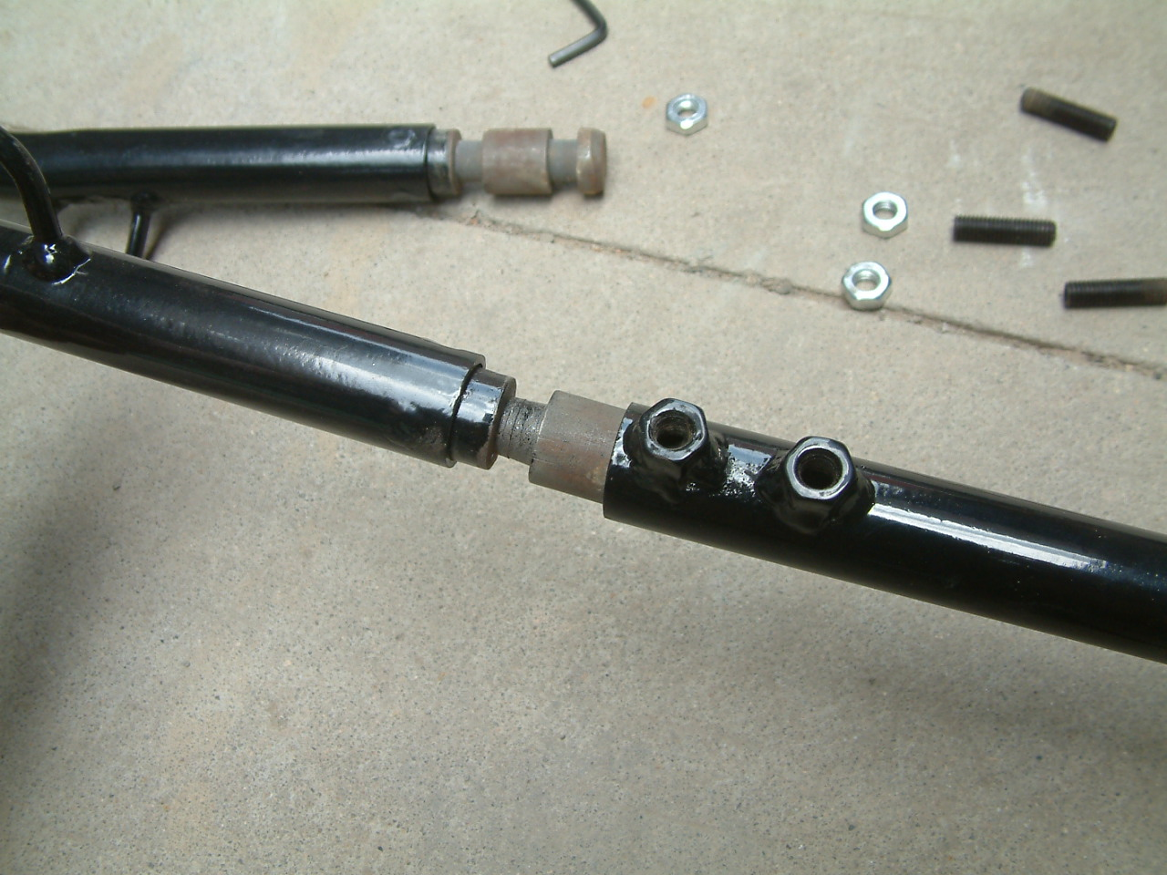 |  | 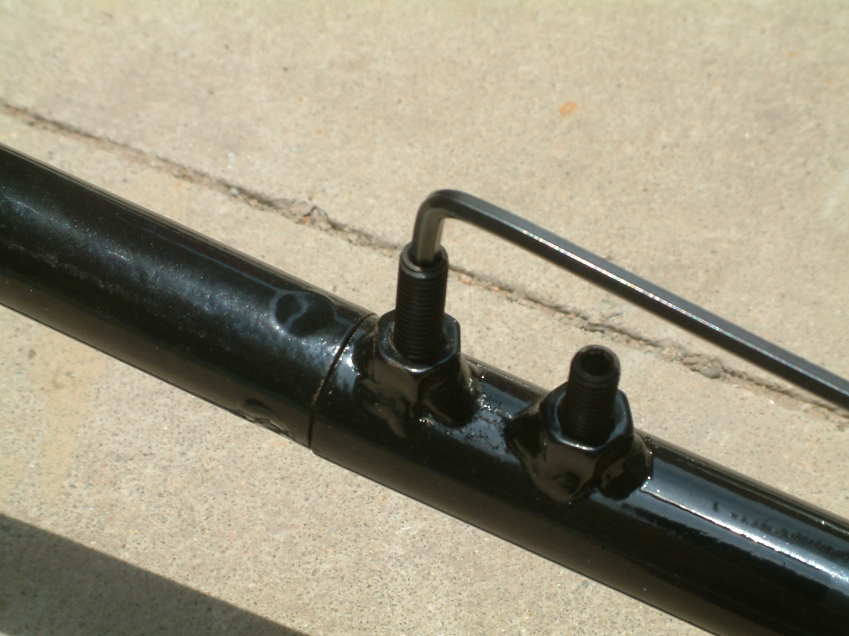 | 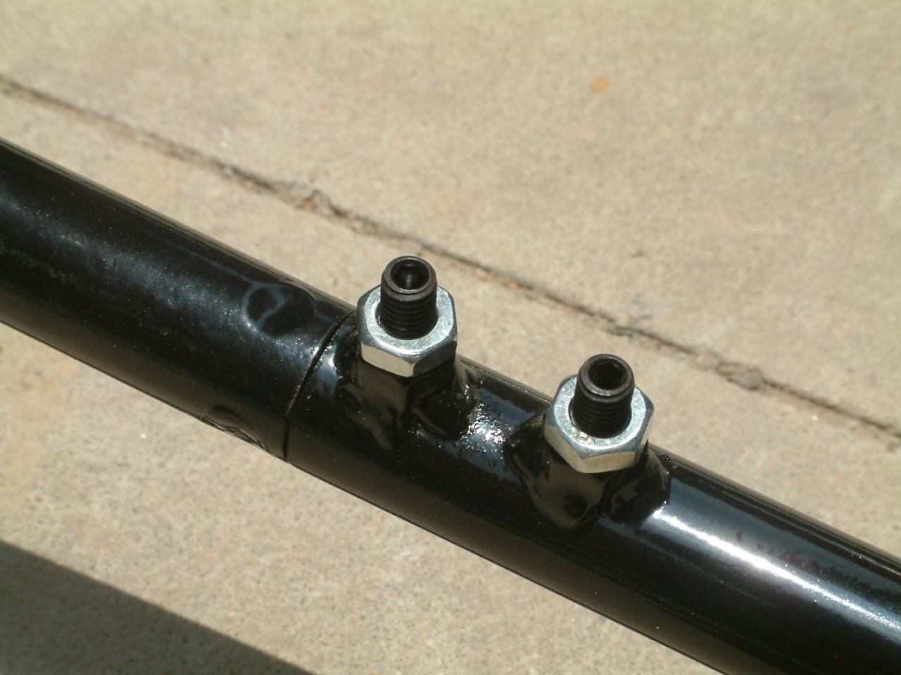
Put (2) into (1) ,adjust the right direction of tip. It must base on your horse’s stature. |  | Tighten the two parts of shaft by bolt, please use the tool to fix them. | Tighten the nut on the bolt, make it close contact the nut that on shaft
FINISHED PICTURE
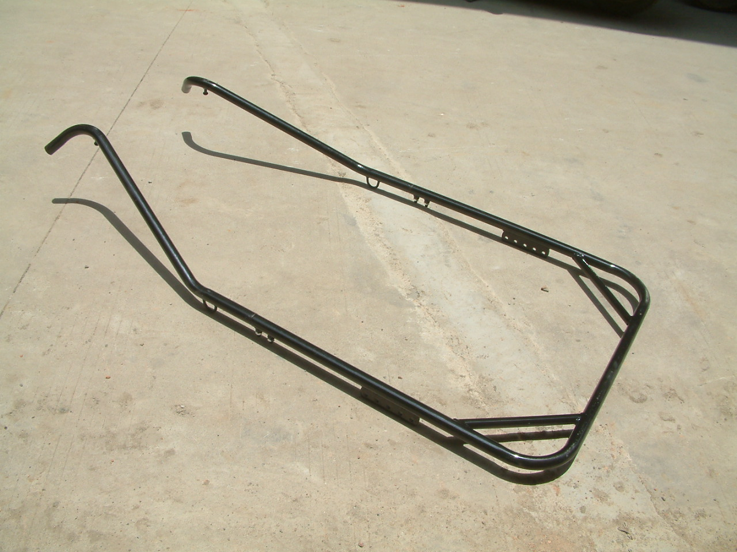
07 style shaft

